Github URL –

<https://github.com/vikrampanth/capstone-p5-udacity>

Docker hub –

<https://hub.docker.com/repository/docker/vikrampanth/capstone-image>

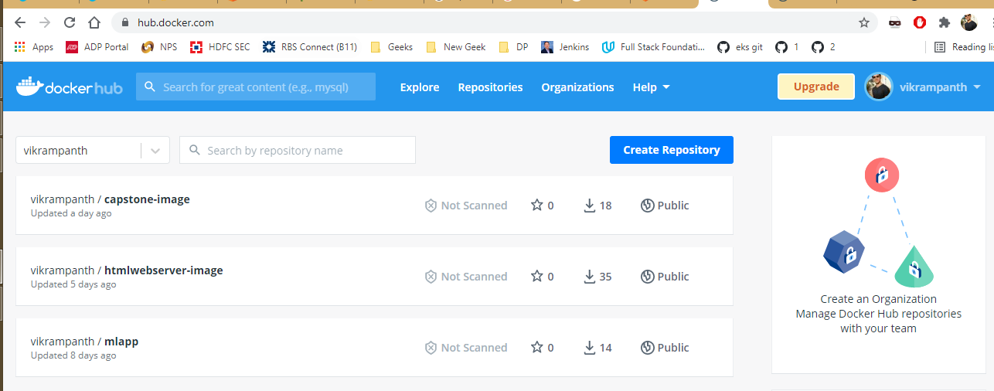

Lint failure -

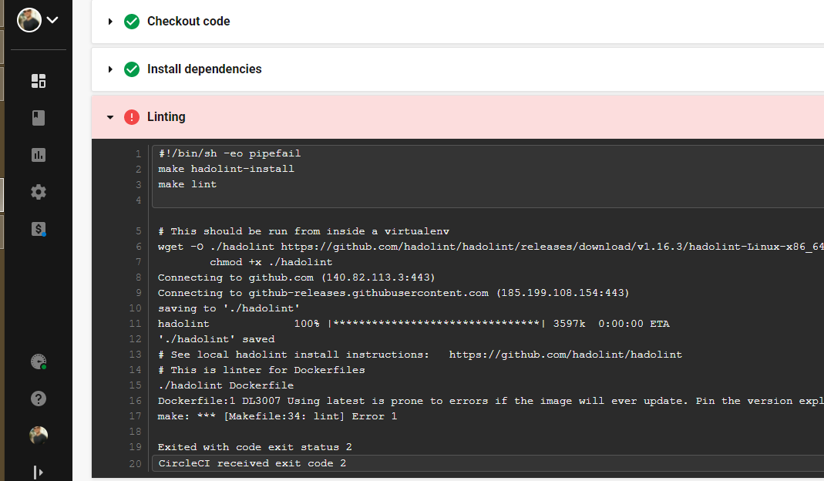

Lint Pass –

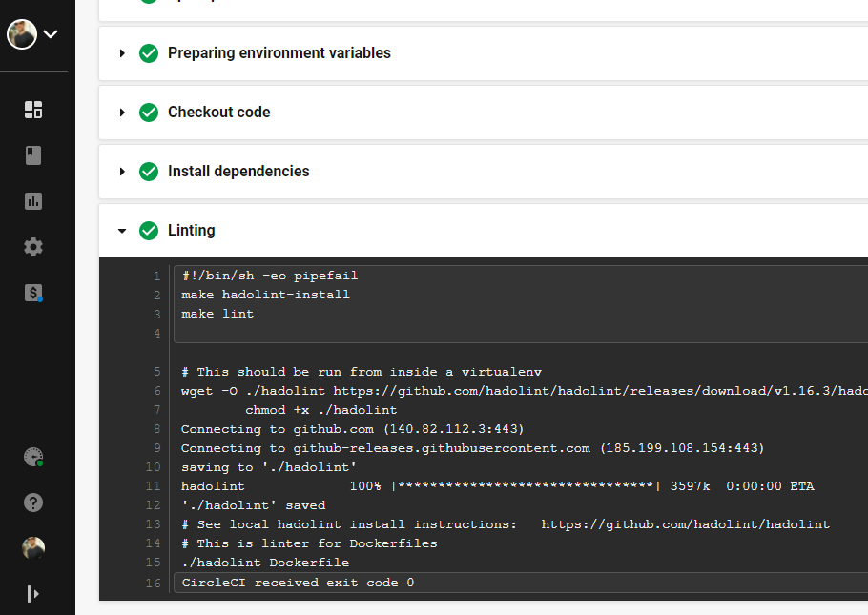

EKS Cluster –

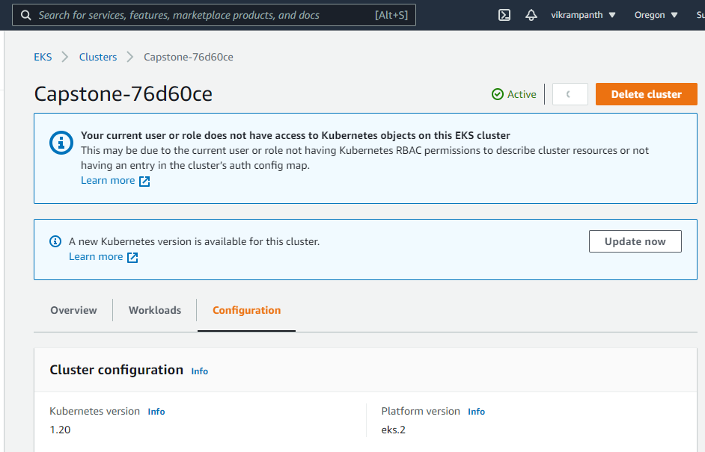

Successful deployment –

Name: capstone-eks

Namespace: default

Labels: <none>

Annotations: <none>

Selector: app=capstone-eks

Type: LoadBalancer

IP Families: <none>

IP: 10.100.116.169

IPs: 10.100.116.169

LoadBalancer Ingress: a6d26a09549f7493b80b9ecb39a8255f-2016078106.us-west-2.elb.amazonaws.com

Port: <unset> 8080/TCP

TargetPort: 80/TCP

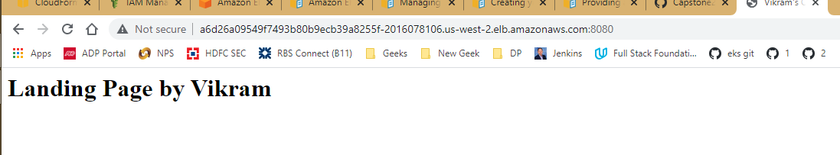

Blue-Green –

NAME TYPE CLUSTER-IP EXTERNAL-IP

PORT(S) AGE

capstone-service LoadBalancer 10.100.20.122 acc3b1bbb8def46e3ba2aca160a02ad3-1236167218.us-west-2.elb.amazonaws.com 8080:32579/TCP 13m

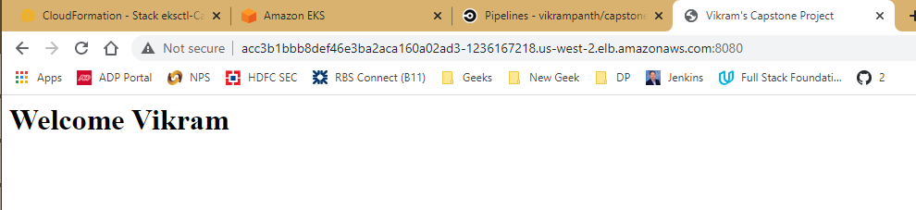

Stack deletion –

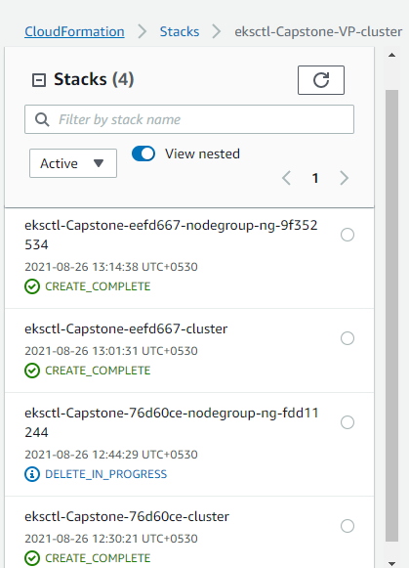

Clean up successful –

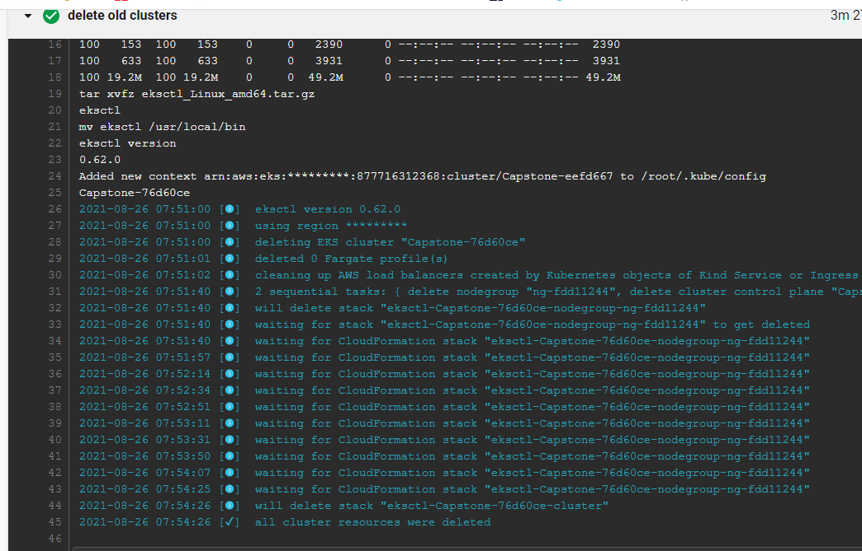

Pipeline Completion –

